

PRODUCT DATA SHEET SS-162
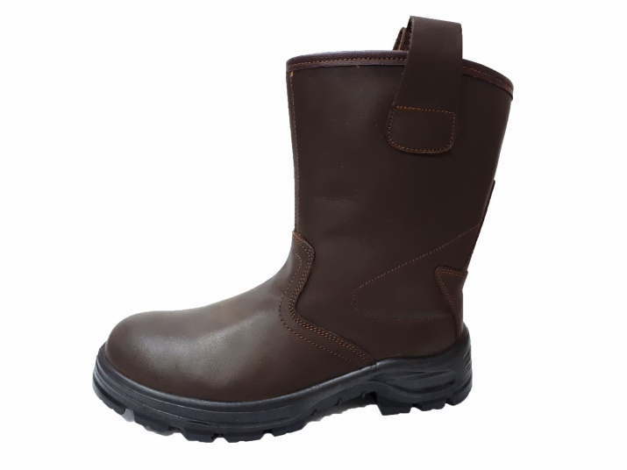
‘WAQ’ BRAND SAFETY SHOE MANUFACTURED AS PER ‘EN ISO 20345:2011’

STYLE /TYPE : SS-162 S3
COLOR : BROWN
UPPER : HAIRCELL S2 (WATER REPELLANT) LEATHER
LINING : NON WOVEN FELT AT VAMP & SKINFIT LINING AT QUARTERS
SOLE : HIGH QUALITY LIGHT WEIGHT DOUBLE DENSITY POLYURETHANE SOLE
WITH ANTISTATIC PROPERTIES
TOECAP : STEEL 200J – EN12568
MIDSOLE : STEEL – EN12568
SIZES : 39 TO 47

FEATURES

- EPOXY COATED STAINLESS STEEL TOE CAP FOR 200 JOULES IMPACT OR STATIC LOAD OF 3500 KGS.
- STAINLESS STEEL MIDPLATE FOR PUNCTURE RESISTANCE.
- INSOLE FOR FLEXIBILITY.
- FULL LENGTH ECO-FRIENDLY MOULDED EVA FOOTBED FOR BETTER COMFORT FOR THE FEET AND SWEAT ABSORBTION.
- SOLE DESIGN FOR ENHANCE GRIP AND PROTECTION.
- WIDE FIT FOR DAY LONG COMFORT.

FEATURES OF POLYURATHANE SOLE

- DUAL DENSITY POLYURATHANE SOLE FOR PROTECTION, COMFORT AND FLEXIBILTY.
2. LOW DENSITY MIDSOLE MADE OF POLYURATHANE FOR MORE COMFORT FOR THE FEET.

3. HIGH DENSITY OUTSOLE MADE OF POLYURATHANE FOR ADDITIONAL SAFETY AND HIGH ABRASION RESISTANCE.
4. RESISTANT TO SLIP, OIL & HEAT.


